Forumium: A Web Based Forum Platform for University Student

Objective
Project Date
Start: 11/11/2025
End: 9/1/2026

By the end of January 2026, we aim to release the first beta version of the forum platform to students for X University by hiring a team of 5 software developers with a budget of RM 150,000.

Technical Result
What to be produced?
Produce a working forum platform with all the requirement following the System Requirement Specification SRS
Specification of final product:
- Login and Logout System
- Change Account Password
- Create Post and Topics
- Search Topics
- Add Comments
- Reply Topics

Work Breakdown Structure Diagram

Activity Table
No. | Activity Description | Activity | Immediate Predecessor | Activity Time(days)
1 | Forum Platform Management and Preparation |  |  | 5
1.1 | Gather Requirement | A | - | 2
1.2 | Project Proposal | B | A | 3
2 | Platform Planning and Design |  |  | 5
2.1 | Establish the selected requirement and design | C | B | 5
3 | Platform Development |  |  | 11
3.1 | Select Technical Framework based on the chosen language | D | B | 2
3.2 | Coding and Debugging | E | D | 7
3.3 | Create Content and Post | F | C | 2
4 | Platform Testing and Rework |  |  | 7
4.1 | Load Forum Content and Integration | G | F | 2
4.2 | Test site | H | E, G | 5
5 | Platform Finalization |  |  | 7
5.1 | Feedback form end user | I | H | 3
5.2 | Debug | J | I | 4
6 | Platform Deployment |  |  | 2
6.1 | Roll Out and Documentation | K | J | 2
7 | Agile Sprint |  |  | 12
7.1 | Creat Backlog from Feedback | L | K | 2
7.2 | Implement Changes | M | L | 10
8 | Platform Launch |  |  | 1
8.1 | Launch Forum Platform | N | M | 1

AON Activity on Node

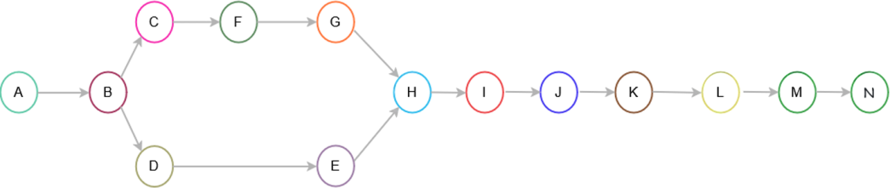

AOA Activity on Arrow
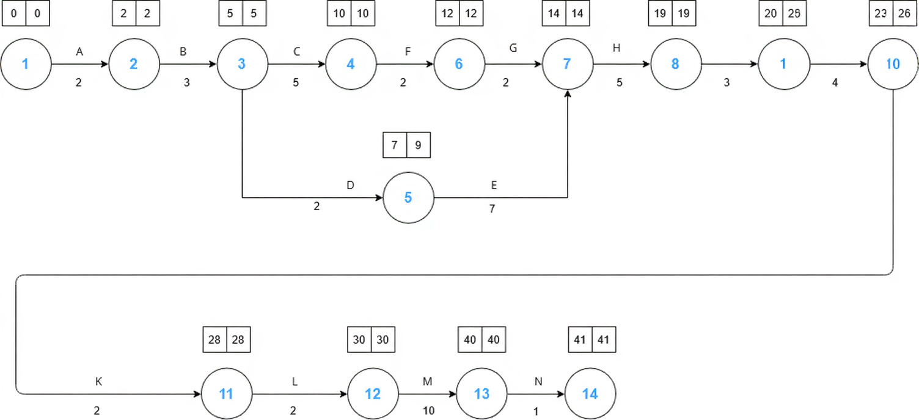
24|24

9

Crictical Path: A-B-C-F-G-H-I-J-K-L-M-N

Milestones
Milestone | Description | Responsible Personnel
Project Start | Define scope, objectives, SDLC model and assign roles | Project Manager
Requirements Completion | Gather requirements, confirm features, finalize tech stack | Lead Designer + Lead Programmer
System Environment Setup | Install server, configure database, install Flarum | Lead Programmer + Entire Team
Core Development | Customize UI, implement categories, install extensions | Lead Designer + Entire Team
Testing Phase | Perform testing, record bugs and do rework | SQA + SCM
Deployment | Deploy forum, finalize server setup | Lead Programmer + Lead Designer
Final Documentation & Presentation | Prepare report, user guide, and slide deck | Documetation Manager + Entire Team

Gantt Chart
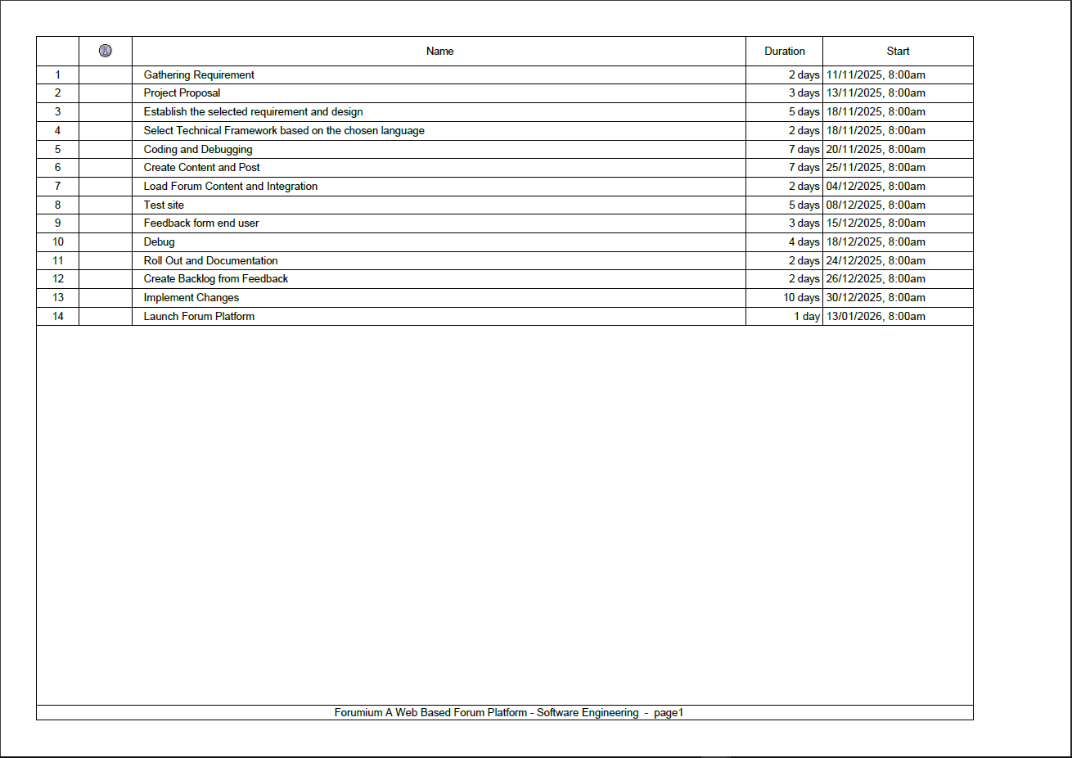

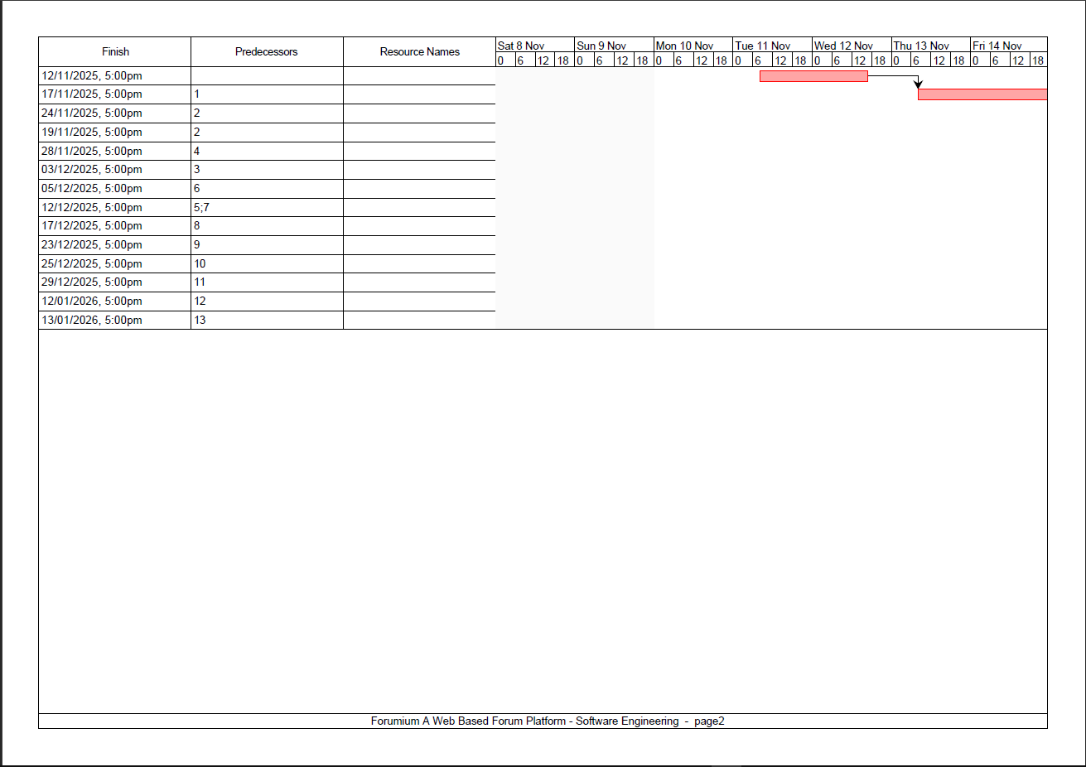
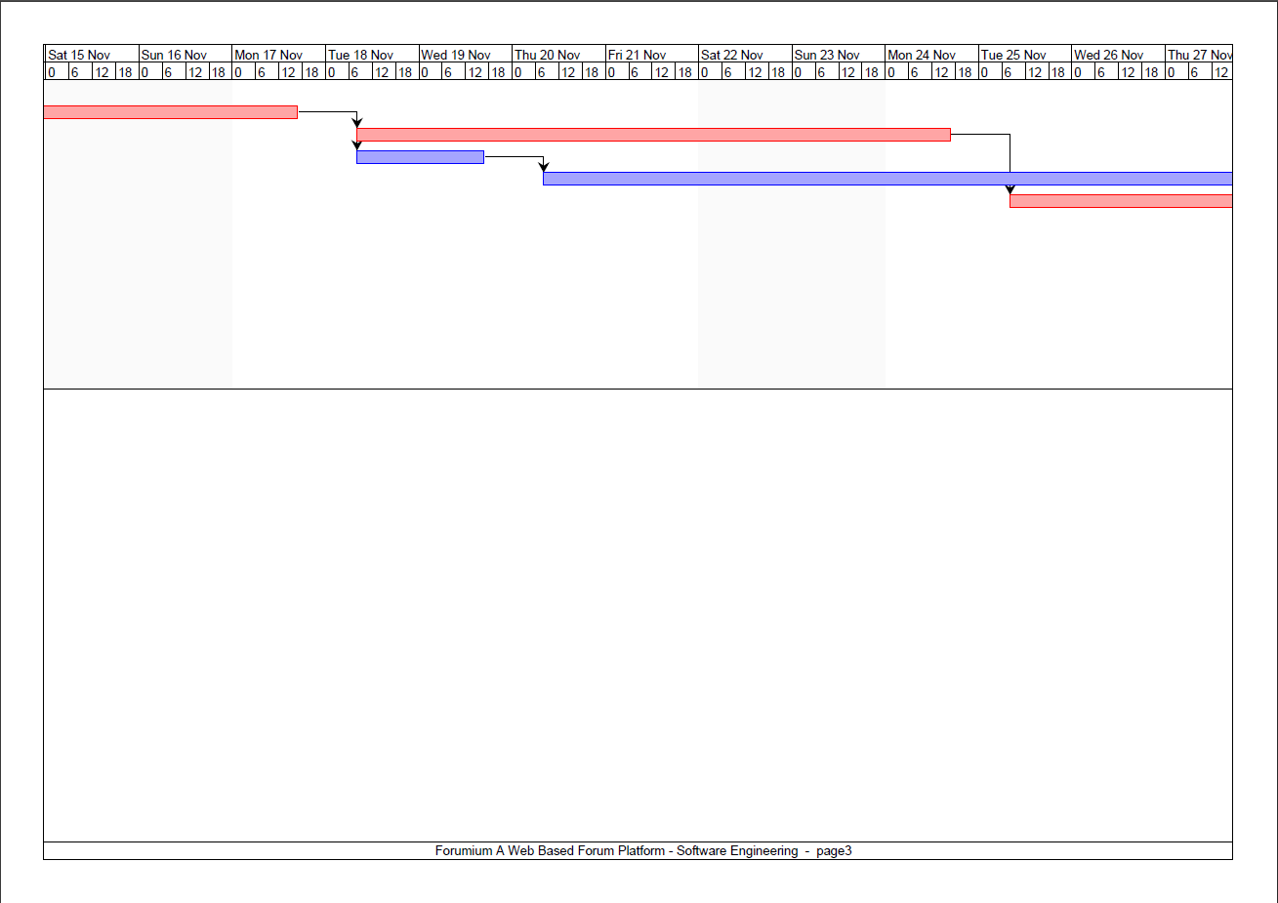
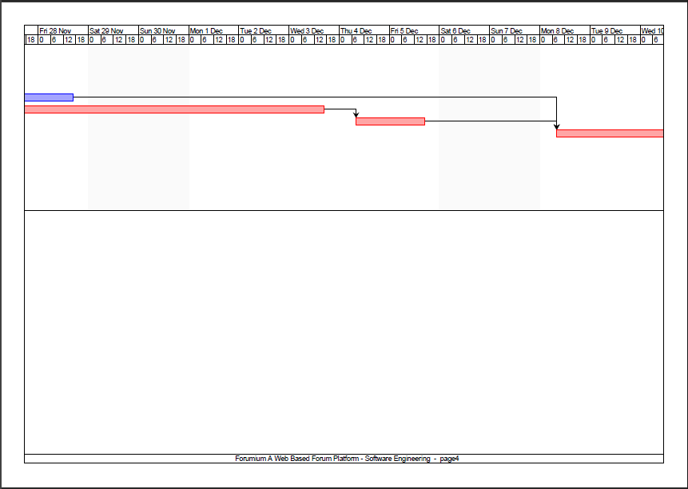
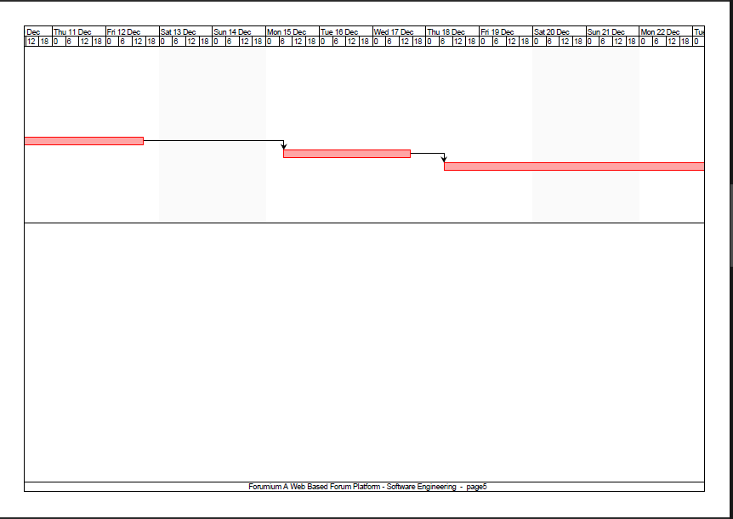
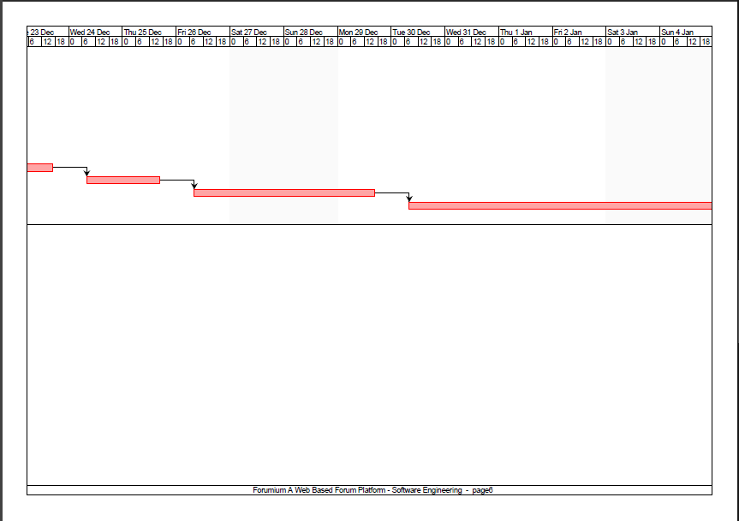
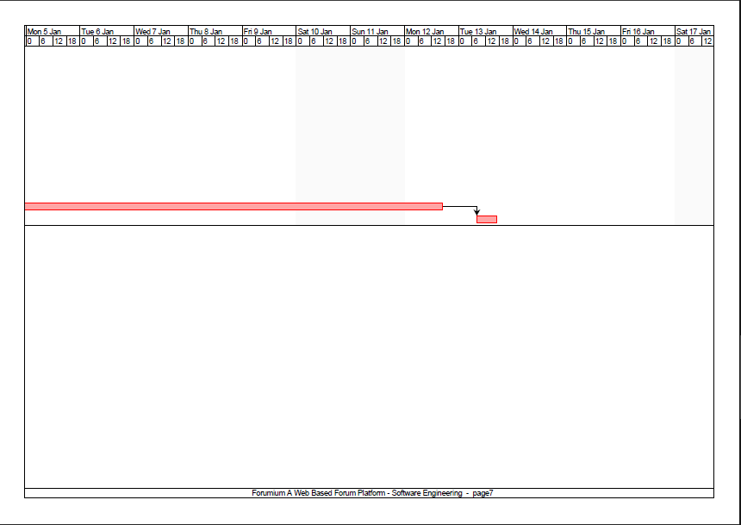

Agile Model
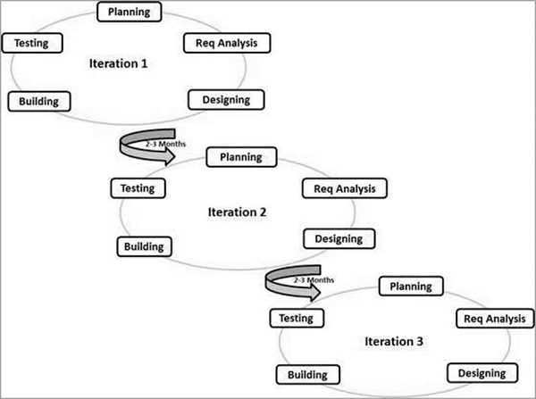

Software Metrics

Software metrics are quantitative measurements that are used to evaluate several facets of a software product, the project as a whole and the development process. These metrics offer useful data for assessing the performance, quality, and advancement of software development. Software metrics are crucial since they serve as a gauge for improving software processes. Software process improvement makes use of software metrics to analyze how the organization aims to accomplish the improvement objectives and how the existing process model may be enhanced. The project metrics are being used to monitor any risks, evaluate the project team's control over the quality of the software work products, and analyze the project's current state. We are using the project metrics to assess the status of our project, track potential risks and evaluate the project team’s ability to control the quality of the software work products.

Project metrics consist of several types namely size-oriented metrics, function-oriented metrics, object-oriented metrics, use-case oriented metrics and web engineering project metrics. Both size-oriented and function-oriented metrics will be used in this project. Size-oriented metrics measure project data, cost, and effort depending on the size of software created. The capability that this program will provide is the foundation for function-oriented metrics. It is an indirect metric that makes use of function points (FP), which can be calculated early in the software development process before the actual lines of code are known. FP can be obtained from a software's needs.

Each statistic has benefits and drawbacks of its own. Advantages of using size-oriented metrics are that it is easily calculated, and useful for projects with similar environments whereas the advantages of using function-oriented metrics is that it is language independent and based on data known early in the project. On the other hand, the disadvantages of size-oriented metrics are that it is language and programmer dependent whereas the disadvantages of function-oriented metrics are that it is more difficult to calculate, difficult to collect data and FP has no physical meaning.

Size Oriented Metrics

Web Application Lines of Code: 5400
Database Lines of Code: 6000
Total Lines of Code/Size: 11.4 kLOC
Project | Effort  (person-month) | Cost (RM) | Size(kLOC) | Doc.  (pages) | Errors | People
Forumium - Alpha 1 | 28 | 500,000 | 12.5 | 700 | 88 | 11
Forumium – Beta 2 | 17 | 360,000 | 11.7 | 650 | 73 | 8
Forumium – Gamma 3 | 13 | 210,000 | 11.4 | 620 | 61 | 5

Metrics | Forumium - Alpha 1 | Forumium – Beta 2 | Forumium – Gamma 3
Productivity =  Size/Effort | 12.5/28 = 0.44 | 11.7/17 = 0.69 | 11.4/13 = 0.88
Quality = Errors /  Size | 88/12.5 = 14.4 | 73/11.7 = 6.2 | 61/11.4 = 5.3
Documentation =  Pages / Size | 700/12.5 = 56 | 650/11.7 = 55 | 620/11.4 = 54

Fuction-Oriented Metrics

The software information domain values have been constructed by our project analysts after
analysing the number of functions based on the parameters listed as the following:

Parameter | Count | Simple | Average | Complex
Inputs | 7 | 8 | 10 | 13
Outputs | 14 | 12 | 7 | 10
Inquiries | 8 | 8 | 13 | 9
Files | 11 | 9 | 8 | 12
Interfaces | 6 | 5 | 9 | 7

Calculating the raw FP value
 | Simple | Average | Complex
Inputs x Count | 8 x 7 = 56 | 10 x 7 = 70 | 13 x 7 = 91
Outputs x Count | 7 x 14 = 98 | 7 x 14 = 98 | 10 x 7 = 70
Inquiries x Count | 8 x 8 = 64 | 13 x 8 = 104 | 9 x 8 = 72
Files x Count | 9 x 11 = 99 | 8 x 11 = 88 | 12 x 11 = 132
Interfaces x Count | 5 x 6 = 30 | 9 x 6 = 54 | 9 x 6 = 54
Raw FP | 347 | 414 | 419

Forr each complexity adjustment factor, a rating on a scale of 0 to 5 is given, as shown below:

Complexity adjustment factors | Rate
F1: Does the system require reliable backup and recovery? | 5 - Essential
F2: Are data communications required? | 4 - Significant
F3: Are there distributed processing functions? | 4 - Significant
F4: Is performance critical? | 4 - Significant
F5: Will the system run in an existing, heavily utilized operational  environment? | 3 - Average
F6: Does the system require on-line data entry? | 5 - Essential
F7: Does the on-line data entry require the input transaction to be built over  multiple screens or operations? | 3 - Average
F8: Are the master files updated on-line? | 4 - Significant
F9: Are the inputs, outputs, files, or inquiries complex? | 5 - Essential
F10: Is the internal processing complex? | 3 - Average
F11: Is the code designed to be reusable? | 5 - Essential
F12: Are conversion and installation included in the design? | 3 - Average
F13: Is the system designed for multiple installations in different  organizations? | 4 - Sigificant
F14: Is the application designed to facilitate change and ease of use by the  user? | 4 - Average
SUM (CAV) | 56

Calculating the FP of each Simple, Average & Complex using the formula below:
FP = Raw FP x [0.65 + (0.01 X CAV)]
- Simple: FP = 347 x [0.65 + (0.01 x 56)] = 419.87
- Average: FP = 414 x [0.65 + (0.01 x 56)] = 500.94
- Complex: FP = 419 x [0.65 + (0.01 x 56)] = 506.99
Calculating the productivity, quality, cost, and documentation of the following projects:
Project | Effort  (person-month) | Cost (RM) | Size(kLOC) | Doc.  (pages) | Errors
Forumium - Alpha 1 | 28 | 500,000 | 12.5 | 700 | 88
Forumium – Beta 2 | 17 | 360,000 | 11.7 | 650 | 73
Forumium – Gamma 3 | 13 | 210,000 | 11.4 | 620 | 61

Alpha 1
Metrics | Simple | Average | Complex
Productivity | 419.87/28 = 14.99 | 500.94/28 = 17.89 | 506.99/28 = 18.10
Quality | 88/419.87 = 0.21 | 88/500.94 = 0.18 | 88/506.99 = 0.17
Cost | 500k/419.87 = 1190.84 | 500k/500.94 = 998.12 | 500k/506.99 = 986.21
Documetation | 700/419.87 = 1.67 | 700/500.94 = 1.40 | 700/506.99 = 1.38

Beta 2
Metrics | Simple | Average | Complex
Productivity | 419.87/17 = 24.7 | 500.94/17 = 29.47 | 506.99/17 = 29.82
Quality | 73/419.87 = 0.174 | 73/500.94 = 0.145 | 73/506.99 = 0.14
Cost | 360k/419.87 = 857.41 | 360k/500.94 = 718.65 | 360k/506.99 = 710.07
Documetation | 650/419.87 = 1.54 | 650/500.94 = 1.30 | 650/506.99 = 1.28

Gamma 3
Metrics | Simple | Average | Complex
Productivity | 419.87/13 = 32.30 | 500.94/13 = 38.53 | 506.99/13 = 38.99
Quality | 61/419.87 = 0.145 | 61/500.94 = 0.12 | 61/506.99 = 0.12
Cost | 210k/419.87 = 500.15 | 210k/500.94 = 419.21 | 210k/506.99 = 414.21
Documetation | 620/419.87 = 1.476 | 620/500.94 = 1.23 | 620/506.99 = 1.22

7.0 - Project Risk Management
Step 1: Possible risk identification
The risks for our projects can be categorized into several categories namely business risks, technical & technology risks, employee risks, development environment risks and customer risks

Business Risks (BR)
- Effect on Company Revenue
The software will be supplied exclusively to the company and will be charged per customer. This will increase revenue for the company. Profits from this project will be used to compensate the employees.

- Delivery Deadline
The delivery deadline for this project which is 24 October is fairly reasonable given that the scope of the project remains unchanged and no changes made to the initial plan.

- End Users
The targeted end users are the general public ranging from various age groups. Therefore, the web application should be made user friendly.

- Documentation that must be provided for customer
Well written and informative documentation should be prepared for the customer as a manual to operate the web application developed. This is because the customer will be given full access to the database, web application, etc.

- Cost of Late Delivery
Late delivery of the application may result in customer dissatisfaction which may either lower our revenue or provide a choice for customers whether or not to accept the web application which is quite risky.

- Cost of Defective Product Delivery: Unknown

Technical & Technology Risks (TTR)
- Are there specific methods used for software analysis?
There are numerous methods that will be used to track and analyse the software progress regularly. Besides that, there will be frequent tests and reviews done to ensure the software is up to expectations. It is further explained in the Software Quality Assurance and Software Configuration Management document.
- Are there any specific software tools being used?
None confirmed yet.
- Are there metrics to be collected in the project?
Yes, particularly size-oriented metrics and function-oriented metrics
Is the technology something new to the organization?
No, the employees have experience working with the technology needed in this software
project.
- Do the requirements need new algorithms or I/O technology?
None for now as in our planning, this project can be completed with the current
technology available.
- Do the requirements need new analysis, design or testing methods?
None for now.
- Do requirements put excessive performance constraints on the product?
No
Customer Risks (CR)
- Does the customer have a solid idea of what is required?
Yes. In a thorough discussion, both parties mutually agreed to the same idea/concept and it was stated in the Software Requirements Specification of the project.
- Is the customer willing to spend time in formal requirements gathering meetings to identify project scope and participate in technical reviews?
Unknown. No inquiry has been made regarding to this matter.
- Does the customer understand the software process and be familiar with the product area?
Yes, the customer had attended a Software Engineering course and had deployed many web applications in the past.
Development Environment Risks
- Are there any sophisticated software tools to be used in this project?
None for now.
- Does the environment make use of the database or a repository?
Yes, it does.
- Have members of the project team received training in each of the tools?
No software tools are identified to be used for now. However, the members are
well-versed with software tools such as Github, Embold and others
- Is there help available in using the tools if needed?
Yes, there are many resources available online but no software tools are being used
currently in our plan.
Employee Risks (ER)
- Are the best people available?
Yes, the most talented software developers, designers, and programmers are on this
project
- Do the people have the required skills
Yes.
- Are there enough people available for this project?
Yes. A small team has been assembled for this project. This improves communication
efficiency as larger teams may not be able to communicate effectively hence reducing
productivity.
- Are all the staff committed to the work?
Yes, they are full-time employees at Flarum with long-term contracts remaining.
- Are the staff well-trained?
Yes

Step 2: Risk Table

Risk Summary | Risk Category | Probability | Impact (1–4) | RMMM (Mitigation + Monitoring + Management)
Slow page load or DB lag | Performance Risk TTR | Medium | 3 | Mitigate: Optimize queries, implement caching.  Monitor: Track response times.  Manage: Add server resources if needed.
Hard to maintain after deployment | Support Risk  TTR | Low | 2 | Mitigate: Write documentation, follow clean coding.  Monitor: Code reviews.  Manage: Assign a support team member.
Features not completed on time | Schedule Risk ER | High | 4 | Mitigate: Break tasks smaller, weekly progress checks.  Monitor: Gantt chart + daily updates.  Manage: Extend deadline or add extra manpower if available.
Late Delivery | BR |  | 1
End Users Resist  System | BR |  | 1
Changes in  Requirements | CR |  | 1
Lack of Database  Stability | TTR |  | 3
Poor Quality  Documentation | BR |  | 2
Deviation from  Software Engineering  Standards | TTR |  | 3
Poor Comments in  Code | ER |  | 2
Extra finance  Required | BR |  | 2

Step 3: Risk Mitigation, Monitoring and Management

Late Delivery
Mitigation
Late delivery may be quite costly to the company in terms of finances and reputation. Therefore, any late delivery would be catastrophic in our point of view. Steps have to be taken for proper delivery of the software product by the deadline. One of the steps we are going to take is to estimate the project scope and set the deadline by assigning tasks to the team while taking into consideration the number of members available for the project including their skills, strengths and weaknesses. It is vital for team members to inform about their progress and address all problems that they have encountered.

Monitoring
A schedule has been established during the planning stage for project monitoring purposes. This schedule will be followed closely by the team and the potential for late delivery is indicated by falling behind schedule.

Management In the worst possible case that the project cannot be completed within the stipulated time, theonly possible solution would be to request an extension from the customerwhich could be detrimental to the company reputation and customer satisfaction & relationship.

End Users Resist System
Mitigation
In efforts of preventing this risk, the web application will be developed with keepingend-users inthe centre of our minds. The ease of use of the UI should be made our top priority.

Monitoring
Various external opinions will be gathered throughout the development process and their
opinions will be further discussed by the developers in the effort of producing the best user
interface possible for the end-users.

Management
In the case that the application failed to be accepted by the end-users, detailed research should becarried out to find reasons for its failure. The results could be used to make amendments to the application and release the new solution.

Changes in Requirements
Mitigation
In efforts to prevent this risk, throughout the project, there will be frequent meetings with the
customer for better understanding between both parties involved. This ensures our product will meet the customer's expectations.

Monitoring
The meeting minutes of each of the meetings held with the customer should be prepared and
managed properly from both sides. Then, both parties should agree to the meeting minutes before the beginning of the next meeting. Through this method, the customers and developers will bewell informed about the project.
Management
If there are any changes in requirements, immediate steps should be taken to solve this problemas quickly and effectively as possible. A meeting should be held between the project team and the customer to rectify this issue.

Lack of Database Stability
Mitigation
The developer who is mainly in charge of the database should always perform error checking.
Upon determining the errors, the issues should be notified to the team and resolved at the
earliest.

Monitoring
Any user who accesses the database should not perform any major modifications without the
supervision of the developer who takes care of the database. At any moment, if an error is
noticed, it should be informed to the team.

Management
If instability is detected with the database, the team should have a meeting to identify the
potential causes and find possible solutions to the issue.

Poor Quality Documentation
Mitigation
The documentation team or manager should constantly be in contact with the developers’ team. In order, to ensure that the documents are developed in a timely manner, the project manager is required to monitor the definition of document standards and mechanisms. Regular meetings should be held regarding the documentation. Any doubts should be clarified instantly. Through these meetings, if a developer finds out if any feature is missing in the documentation, it could be added too after consideration. Besides that, the testing team should do the test using this documentation and let the documentation team know about the quality of the documentation prepared for the software.

Monitoring
The development team and the testing team should always watch out for any topics about the
software which may have not been included.

Management
If poor quality is detected, there should be an attempt made by the entire team to improve the
quality of documentation by adding certain required topics or removing any redundant topics.

Deviation from Software Engineering Standards
Mitigation
It is very unlikely to occur since the team involved in this project is quite experienced and have a thorough understanding of the software engineering standards.

Monitoring
Technical reviews will be held regularly to ensure the documentation and actual project is
consistent with each other. All the documents needed should be completed as accurately as
possible which guarantees the team’s compliance to software engineering standards.
Management
To handle this issue, the project must be modified in a way that it complies with the standards.
Technical reviews can be used to determine how to make the project in line with set standards.

Poor Comments in Code
Mitigation
Certain commenting standards should be established by the lead programmer to ensure good
quality code is produced.

Monitoring
The code should be review and the reviewers will determine if the comments given
for the code is appropriate. This ensures that good quality code is created.

Management
If the code quality is detected to be low, then the programmers should perform the necessary
actions to improve the code. Constant close monitoring of the code will reduce the possibility of poor comments in the code. Programmers could resolve this issue by simply modifying the
comments placed or adding new comments.

Extra Finance Required
Mitigation
In future, due to unforeseen circumstances or improper planning, there may be a need for extra money. As a precautionary measure, there could be a reserve fund allocated for such unexpected scenarios.

Monitoring
The finance team should always monitor the cash flow associated with the project and alert the project team in the event of exceeding the allocated budget.

Management
In the case that extra finance is required, the project manager should have a meeting with the
project sponsor and request extra funds. However, this is very unlikely to happen given that the team have handled few similar projects successfully.

Step 4: Risk Map

Risk Map
Level of Likelihood | Almost Certain
Level of Likelihood | Likely |  | TTR3 | BR3 TTR1 ER2
Level of Likelihood | Possible |  |  |  | BR1
Level of Likelihood | Unlikely | ER1 |  | BR4, CR1 | BR2
Level of Likelihood | Rare |  | TTR2, TTR4
 |  | 4- Negligible | 3- Marginal | 2- Critical | 1- Catastrophic
 |  | Level of impact

Legend
Risk Rating | Low | Moderate | Significant | High | Extreme

Business Risk (BR)
BR1 | Late Delivery | High | P-Possible,  1-Catastrophic
BR2 | End User Resist System | Significant | U-Unlikely,  1-Catastrophic
BR3 | Poor Quality Documentation | High | L-Likely, 2-Critical
BR4 | Extra Finance Required | Moderate | U-Unlikely, 2-Critical
Customer Risk
CR1 | Changes in Requirement | Significant | U-Unlikely, 2-Critical
Technical and Technology Risk (TTR)
TTR1 | Lack of Database Stability | High | Likely, 2-Critical
TTR2 | Deviation from Software Engineering Standards | Low | Rare, 3-Marginal
TTR3 | Hard to maintain after deployment | Moderate | Likely, 3-Marginal
TTR4 | Slow page load or DB lag | Low | Rare, 3-Marginal
Employee Risk (ER)
ER1 | Poor Comments in Code | Low | U-Unlikely, 4-Negligible
ER2 | Features not completed on time | Significant | Likely, 2-Critical

Risk Profile

Risk | Likelihood | Impact | Risk Rating | Mitigation Plan
Business Risk
BR1 - Late Delivery  Scope: Late delivery may  be quite costly to the  company in terms of  finances and reputation. | P-Possible  Justification:  An inadequate number  of team members.  Large project job  scope. | 1- Catastrophic  Justification:  Effects on the reputation. Service  shortfall incurs a  penalty. | High | Estimate the project scope and set the deadline by assigning tasks to the team while taking into consideration the number of members available for the project including their skills, strength and weaknesses.
BR2 - End User Resist System  Scope: The final product  is undesired by the  customer. | U-Unlikely  Justification:  The client signed the  agreement and  accepted the tender | 1- Catastrophic  Justification:  This will greatly  postpone the  application work  schedule. | Significant | Development should keep end-users in the centre of our minds. The ease of use of the UI should be made our top priority.
BR3 - Poor Quality Documentation  Scope: Documentation  work, if any, are unrelated  to the overall project. | L-Likely  Justification:  The company prioritises working product rather than proper documentation. Early stages can be ad-hoc. | 2-Critical  Justification:  Poor documentation  will lead to trouble in  audit and testing  stages. | High | The documentation team will work closely with the developers’ team. Regular meetings held to monitor the definition of documentstandards and mechanisms.
BR4 - Extra Finance Required  Scope:  Change requirements, late  deadlines will increase  cost of project. | U-Unlikely  Justification:  The cost budget is  planned out according  to requirements. The  finance team monitors  the cash flow. | 2-Critical  Justification:  Without cash flow, the  project schedule will  be delayed. | Moderate | As a precautionary measure, there could be a reserve fund  allocated for such unexpected scenarios.
Customer Risk
CR1 - Changes in  Requirements  Scope:  Clients may request for  huge changes that  overhauls the project. | U-Unlikely  Justification:  Tender project is  clearly defined by the  client side. | 1-Catastrophic  Justification:  Sudden changes of  requirement increases  cost and delays final  product launch. | Significant | Frequent meetings held with the customer for clear  communication.
Technical and Technology Risks
TTR1 - Lack of Database  Stability  Scope: Database has to  handle occasional user  spikes, while not  sacrificing its efficiency  and speed. | L-Likely  Justification:  Database deployment  requires a backend  team, with clear  communication with  the rest of the  developers. | 2-Critical  Justification:  A web app without the database is as good as a sitting duck. | High | Perform error checking regularly. Upon determining  the errors, the issues should be notified to the team and  resolved at the earliest.
TTR2 - Deviation from  Software Engineering  Standards  Scope: Software  Engineering is a  discipline that practices  the best way to develop  software. | R-Rare  Justification:  The management and  developer teams have  been well-trained in  regards to standards  compliances. | 3-Marginal  Justification:  The project's main  concerns are proper  documentation and a highly reliable  working product. | Low | Have a thorough understanding of the software engineering standards.
TTR3 - Hard to maintain after deployment  Scope: It specifically affects the engineering team's ability to fix bugs, implement new features, and scale the platform as the user base grows. | Likely  Justification:  Forums often rely on third-party plugins or rapid prototyping to get features live, leading to "spaghetti code." Its point to Rapid Development Cycles | 3 - Marginal  Justification:  While maintenance difficulties are frustrating for developers, the immediate impact on the end-user is low. | Moderate | Shift toward a microservices or modular monolith approach. This ensures that the "User Authentication" module is independent of the "Forum Categorization" module.
TTR4 - Slow page load or DB lag  Scope: Latency experienced by the end-user. It covers front-end rendering JavaScript/CSS weight and back-end bottlenecks, such as unoptimized SQL queries, lack of indexing, or server resource exhaustion during peak traffic. | Rare  Justification: For a new platform, the volume of data and concurrent users is typically well within the hardware's capabilities. | 3 - Marginal  While a slow site is annoying, it is considered "marginal" because it does not result in data loss or security breaches. Users might experience a "jerkier" interface or wait an extra second for a thread to open, but the core utility of the forum remains intact. | Low | To ensure performance remains high even as the community grows by implementing lazy loading for long forum threads so that only the first few comments load initially, reducing the initial payload.
Employee Risks
ER1 - Poor Comments in  Code  Scope: The comments in  the code poorly explained the functionality enough. | U - Unlikely  Justification:  The developers  practice a standard of  commenting. | 4-Negligible  Justification:  The source code is not the priority of the client. | Low | Lead programmer establishes a  commenting standard that will  be followed by the rest of the  developers.
ER2 - Features not completed on time  Scope: Involves the product roadmap and the development lifecycle. This includes the design, coding, testing, and deployment phases for specific milestones | L - Likely  Justification:  Software complexity is often underestimated; unforeseen technical hurdles like integrating a specific API or fixing a complex bug which frequently extend timelines. | 2 - Critical | Significant | Break down large tasks into smaller, manageable two-week sprints. This allows for frequent progress checks and early detection of delays using Agile or Sprig Methodology

Conclusion
Project Risk Rating: High Risk
(3 High, 2 Significant, 1 Moderate, 2 Low)
Contributing Factors
a) Inadequate number of team members combined with a large project job scope.
b) Company culture prioritizes a working product over proper documentation; early stages tend to be ad-hoc.
c) Database deployment requires a dedicated backend team, necessitating clear communication with all other developers.
Recommendations

a) Estimate the total project scope and establish a realistic deadline by assigning specific tasks to the team while accounting for the current headcount.
b) Integrate the documentation team closely with the developers; hold regular meetings to bridge the gap between code and records.
c) Perform database error checking regularly and resolve any identified issues at the earliest possible stage.
d) Set up a reserved fund as a precautionary financial measure.

Key Areas for Attention
a) Legal Guardrails: Contract T&Cs must include a review of penalty clauses, inclusion of limitation of liability, clear conditions/methodology for penalty imposition, and defined reciprocal responsibilities.
b) Stakeholder Clarity: Define clear roles and responsibilities between the Flarum platform team and the client.
c) Commercial Health: Ensure the profitability and long-term sustainability of the chosen business model.
d) Governance: Maintain effective project management throughout the lifecycle.
e) Oversight: Implement rigorous project progress tracking, frequent reviews, and active monitoring.

Software Cost Estimation and Risk Analysis
Task List includes:
- Set up project environment and development
- Design database and source code
- Implement core features (posting, replying, user accounts)
- Test everything and rework
- Final Deployment
- Time Estimation

Activity | Immediate  Predecessor | Optimistic (O) | Most Likely (M) | Pessimistic (P) | Duration E (days)
Set up environment | – | 3 | 6 | 10 | 6
Design database | 1 | 6 | 10 | 16 | 10
Implement core features | 2 | 13 | 23 | 32 | 23
Test features | 3 | 3 | 6 | 13 | 7
Deploy project | 4 | 2 | 3 | 7 | 4
Total |  |  |  |  | 50 days

Impact Level:
1 - Catastrophic 2 - Critical 3 - Marginal 4 - Negligible

For the time estimation for the Risk Analysis focuses on the Development, Testing, and Deployment phases, as these stages carry the highest uncertainty and potential impact to the project schedule.

